Chosen Web Development Project Proposal
Web Development
WEDE5020
Nozithelo Ntini
ST10519223
Group 2

Table of Contents
1. Chef Nozy Organisation Overview: 2
Organisation History 2
Mission statement 3
Vision statement 3
Target audience 3
2. Website goals and objectives. 3
Key Goals 3
Key Performance Indicators (KPIs) 3
3. Current Website Analysis 4
Strengths of Current Online Presence 4
Weaknesses 4
Areas for Improvement 4
4. Proposed Website Features and Functionality 4
5. Design and User Experience 5
Colour Scheme 5
Typography 6
Layout and Design 7
User Experience Considerations 7
Low-Fidelity Wireframes 8
6. Technical Requirements 8
Programming Languages and Technologies 8
7. Timeline and Milestones 9
8. Budget Estimate 9
References 10

- Chef Nozy Organisation Overview:
Name: Chef Nozy
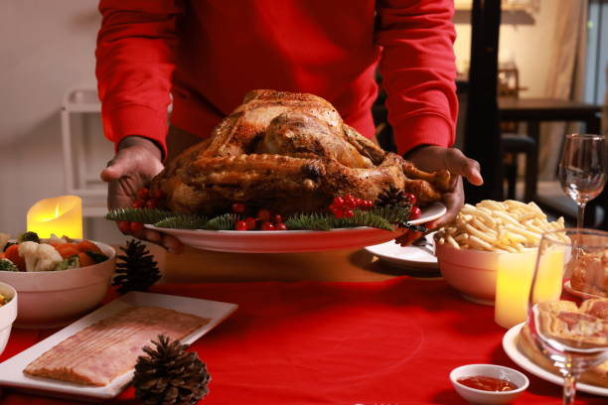
(Inthapong, 2022)

Organisation History
Chef Nozy is a small culinary business that was founded in 2022 that focuses on providing personalised food experiences for private events, small gatherings and special events. The brand was created to offer customers a personal and intimates dining experience compared to traditional catering services like restaurants.
The business focuses on fresh, high quality meals prepared with attention to detail. Services that Chef Nozy provides include private dining, event catering and customised menu planning for customers who want a unique and exciting food experience.
Although the business is still in its beginning stages the goal is to build a strong underline presence that allows potential clients to discover types of services provided explore and make booking enquiries.

Mission statement
To create memorable dining experiences through personalised service, quality ingredients and customised menus.

Vision statement
To be a trusted personal chef known for delivering customised and exciting culinary experiences for private clients and small events.

Target audience
The main target audience includes:
- Young professionals who host dinner parties.
- Families hosting celebrations.
- Clients planning small events. Individuals looking for private chef services.
- Foodies interested in curated dining experiences
- Website goals and objectives.

Key Goals
- Increase visibility of the Chef Nozy brand online.
- Provide clear information about services and menus.
- Allow potential clients to submit booking enquiries
- Show previous work and food presentations and portfolios.
- Build credibility within the culinary space.

Key Performance Indicators (KPIs)
The success of the website will be measured using the following KPIs.
- Number of monthly website visitors.
- Number of enquiry form submissions.
- Number of confirmed bookings from the website.
- Current Website Analysis
Chef Nozy does not have a web site as of now. They mainly have a presence on social media where images of dishes and event catering are posted. The brand is currently using social media platforms like Instagram and WhatsApp for business.

Strengths of Current Online Presence
- A visual content that shows food presentation.
- Being able to engage directly with their followers.
- Ability to share updates and promotions in real time.

Weaknesses
- Clients are unable to view available services.
- There is no structured menu info.
- It is difficult for clients to submit a formal booking request/enquiry.
- Without a website, they risk losing professionalism and being taken seriously as a brand.

Areas for Improvement
Creating a website will help the business display information in a more organised manner and facilitate potential clients to enquire about the services easily.
- Proposed Website Features and Functionality
The website will include several essential pages designed to provide clear information and encourage user interaction.
Homepage
- Introduction to the brand
  - Overview of services
  - Featured food images
About Page
- Background of Chef Nozy
- Culinary philosophy
- Brand story
Services Page
Detailed description of available services such as:
- Private dining experiences
- Event catering
- Custom menu planning
- Meal prep services
Menu / Gallery Page
  - Sample menus
  - Images of previous dishes and events
Contact page with form where clients can submit booking requests
  - Fields for event date, guest numbers and dietary requirements
  - Contact Page
  - Email contact
  - Social media links
  - Business contact details
- Design and User Experience
The design of the website will reflect a modern, clean and visually appealing culinary brand.

Colour Scheme
The proposed colour palette will include:
- Warm neutral tones
- Soft beige/cream backgrounds
- Black text
- Accent colour like gold
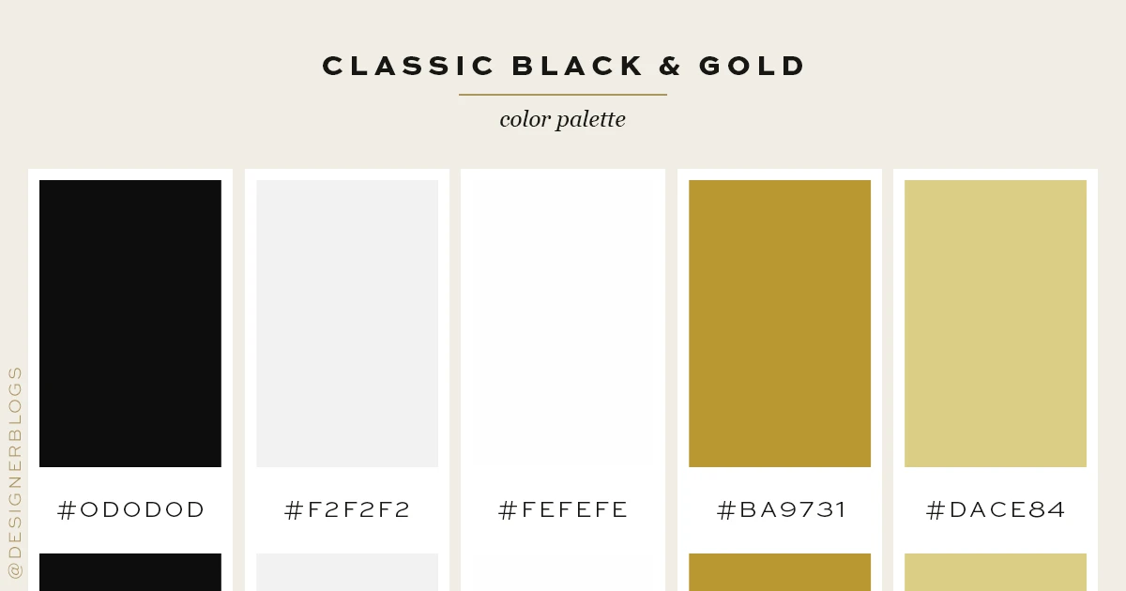 (Designer Blogs, 2024)

Typography
Proposed font choices include:
Headings: Playfair Display
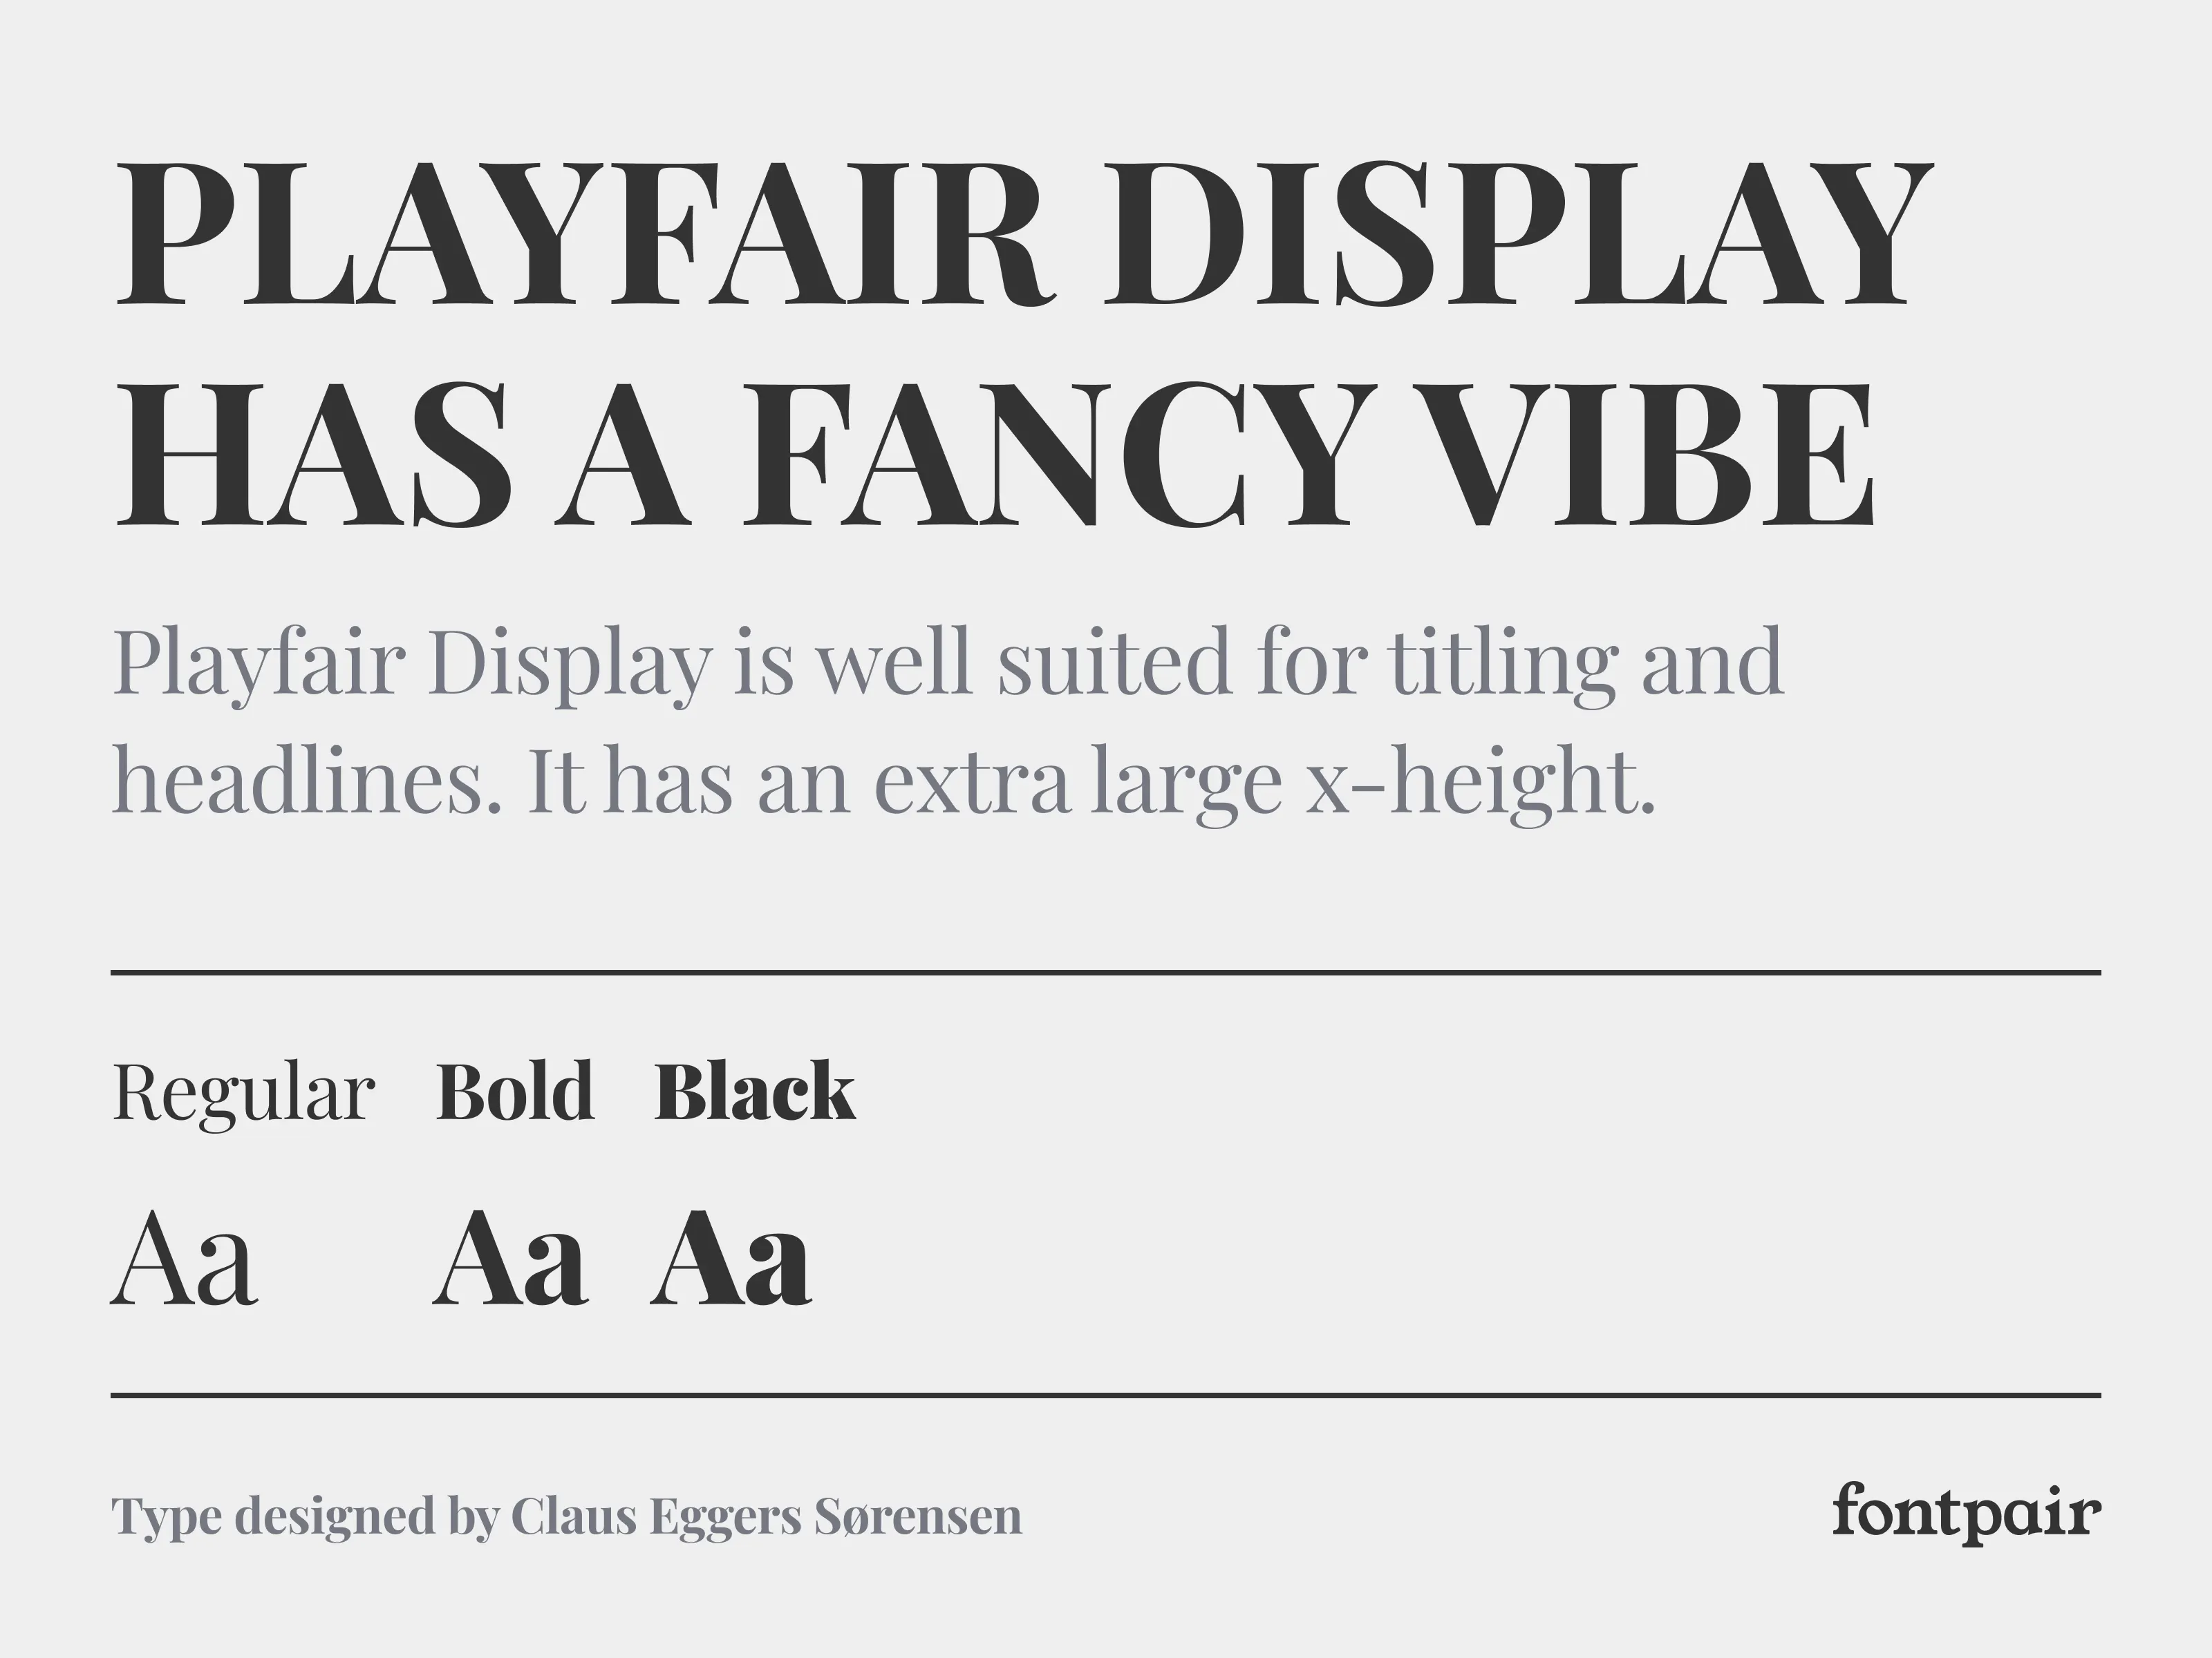
(Dribbble, n.d.)
Body text: Open Sans
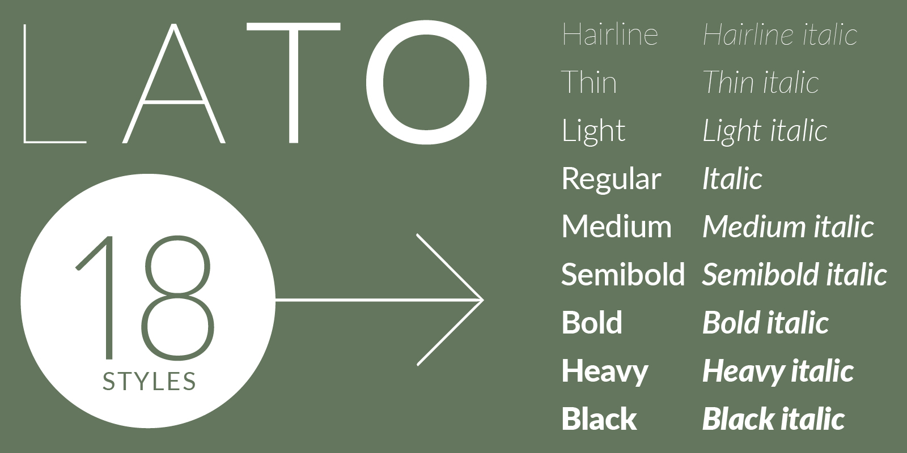
(Twardoch, et al., n.d.)

Layout and Design
The layout will be simple and easy to navigate. Key design principles include:
- Clear navigation menu
- Large visual images of food
- Structured content sections
- Mobile friendly vs Desktop layout

User Experience Considerations
Important considerations include:
- Easy navigation between pages
- Clear booking instructions
- Fast loading pages
- Mobile responsiveness
- Simple enquiry form

Low-Fidelity Wireframes
Website Layout will follow this outline:
- Technical Requirements
The website will be developed using standard web development technologies.
Hosting and Domain
Domain example: chefnozy.co.za
Web hosting through providers such as Afrihost or xneelo

Programming Languages and Technologies
The website will be built using:
- HTML
- CSS
- JavaScript
These technologies allow for a responsive and interactive website while remaining suitable for the scope of the project.
(Wandrag, 2023).
- Timeline and Milestones
Phase | Milestone | Estimated Time
Planning | Proposal approval | Week 1
Research | Content gathering and structure planning | Week 2
Design | Wireframe development | Week 3
Development | HTML, CSS, and basic functionality | Week 4
Testing | Debugging and usability testing | Week 8
Final Submission | Project completion | Week 10
(Mika, 2026) ((IIE), 2026)
- Budget Estimate
Item | Estimated Cost
Domain Registration | R120 – R200 per year
Website Hosting | R100 – R200 per month
Website Development | R4,000 – R8,000 once off
Maintenance | R500 – R1,000 per month
(OpenAI, 2026)

References
(IIE), T. I. I. o. E. U., 2026. WEB DEVELOPMENT WEDE5020 POE. [Online]
Available at: <https://advtechonline.sharepoint.com/:w:/r/sites/TertiaryStudents/_layouts/15/Doc.aspx?sourcedoc=%7BF3EFB2BA-E0FA-4B85-B2F0-644C7BC04F04%7D&file=WEDE5020POE.docx&action=default&mobileredirect=true>
[Accessed 13 March 2026].
Designer Blogs, 2024. Color Love Classic Black & Gold. [Online]
Available at: <https://www.designerblogs.com/color-love-classic-black-gold/>
[Accessed 12 March 2026].
Dribbble, n.d. Playfair Display - Serif Google Font. [Online]
Available at: <https://dribbble.com/shots/15345206-Playfair-Display-Serif-Google-Font>
[Accessed 10 March 2026].
Inthapong, o., 2022. Close up hand holding Baked chicken serve on luxury dining table, Christmas eve celebration or party preparation concept ,roasted Chicken. Christmas and New Year food concept stock photo. [Online]
Available at: <https://www.istockphoto.com/photo/close-up-hand-holding-baked-chicken-serve-on-luxury-dining-table-christmas-eve-gm1432374587-474649664>
[Accessed 10 March 2026].
Mika, A., 2026. Website Development Timeline. [Online]
Available at: <https://www.ramotion.com/blog/how-long-to-develop-website/>
[Accessed 11 March 2026].
OpenAI, 2026. Chat-GPT (Version 5.3). [Online]
Available at: <https://chatgpt.com/>
[Accessed 11 March 2026].
Twardoch, A., Nikoltchev, B. & Dziedzic, Ł., n.d. Lato. [Online]
Available at: <https://fonts.adobe.com/fonts/lato>
[Accessed 10 March 2026].
Wandrag, J., 2023. The Benefits of Learning Vanilla HTML, CSS, and JavaScript as a Wizard. [Online]
Available at: <https://medium.com/@jason_wandrag_the_web_wizard/the-benefits-of-learning-vanilla-html-css-and-javascript-as-a-wizard-fe62d08b8624>
[Accessed 12 March 2026].

